Termeow Backend Architecture and Streaming Plan
Voice-authored automations with low-latency onchain intelligence and policy-controlled execution
Decision. Use Helius Enhanced WebSockets for the Solana hot path and Alchemy WebSockets for Robinhood Chain. Evaluate armed rules in memory, sign within Privy policy, and keep queues and databases outside the synchronous decision path. Helius webhooks, Cloudflare Queues, Neon, and R2 provide recovery, control state, and inexpensive history.

System outcome
A trader can describe an automation naturally, inspect a precise rule, approve bounded authority once, and leave the system to monitor and execute. The backend converts conversation into deterministic predicates, evaluates them against live chain-derived market state, and produces an auditable execution without relying on the language model at trigger time.
- Fast: live sockets, incremental calculations, dependency-indexed rules, and regional transaction submission.
- Lean: one normalized event model for the voice agent, automation engine, live feed, and analytics.
- Controlled: Privy signer policies, spend caps, allowed programs, expiry, slippage, and idempotency.
- Recoverable: confirmed webhooks and replay reconcile gaps without slowing the hot path.

End to end backend flow
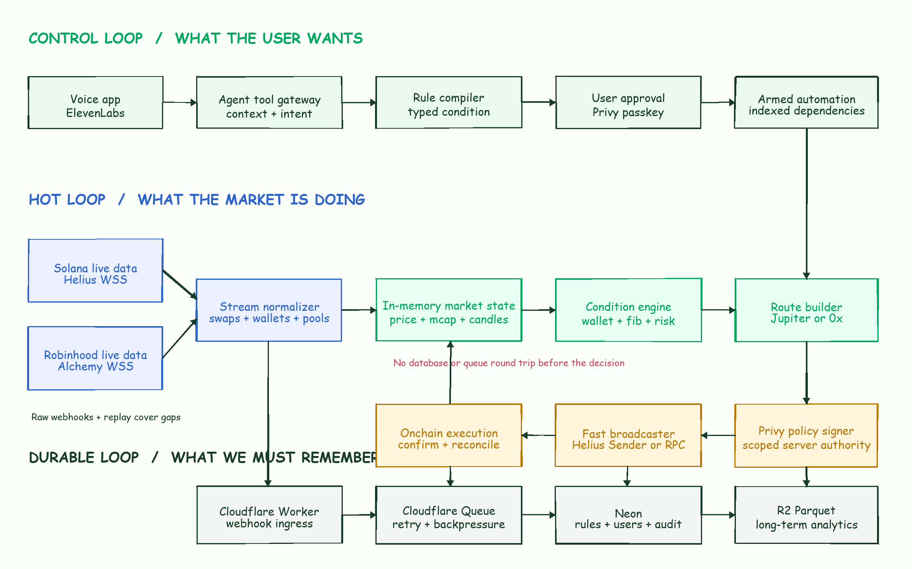
Figure 1 Termeow control, market, execution, and durable data loops

Control loop from voice to an armed rule
- The voice application sends the transcript, authenticated user identifier, wallet set, and a compact market snapshot to the agent tool gateway.
- The agent resolves named traders and wallets through the curated identity index. It asks only for missing choices that change risk or execution.
- The rule compiler turns the intent into a versioned condition document. Natural-language explanation remains presentation data, never executable logic.
- The client displays a separate confirmation surface containing entry, exits, size, expiry, slippage, chain, router, and authorization limits.
- The user approves with a Privy passkey. The backend attaches the restricted automation signer and policy, records the approval, and marks the workflow armed.
- The dependency index adds the rule under its wallets, tokens, pools, programs, and market series so unrelated events never evaluate it.

Condition model
Condition family | Typed inputs | Live dependency | Example behavior
Wallet activity | wallet or handle, side, minimum size, first buy, entry tolerance | Wallet transaction stream | Buy within 25 percent of a tracked trader entry
Price structure | cross, reclaim, close, timeframe, tolerance | Incremental candles | Close above a one hour level after touching it
Fibonacci | swing method, direction, level, confirmation, invalidation | Confirmed pivots and candles | Buy a 0.618 bounce from the latest confirmed rally
Valuation | FDV or circulating cap, lower and upper bounds | Supply snapshot and USD price | Execute only from 1 million to 5 million dollars
Market quality | liquidity floor, impact, slippage, route freshness | Pools and route quotes | Abort if quoted impact exceeds 8 percent
Exit chain | take profit, stop, trailing rule, time stop | Successful parent execution | Arm exits only after the buy lands

Questionnaire answers should populate reusable trader defaults: preferred confirmation style, swing interpretation, acceptable liquidity, scaling behavior, invalidation logic, and exit discipline. Every automation stores the defaults it inherited so later preference changes cannot silently alter an armed rule.

Live market data plane
Need | Recommended source | Role | Cost posture
Solana hot detection | Helius transactionSubscribe | Processed wallet, program, account, and transaction events for armed rules | Use existing paid allowance; tightly filter payloads
Solana recovery | Helius raw webhooks | Confirmed delivery, missed-event reconciliation, broad watchlists | One credit per delivered event; batch webhook edits
Solana scale or shadow | Alchemy Yellowstone gRPC | Filtered high-throughput stream and reconnect replay | $75 per TB, prorated, with no minimum
Robinhood Chain | Alchemy WebSocket | newHeads and filtered logs for wallets, routers, and pools | Covered by the existing Alchemy plan
Metadata and identities | Termeow gateway | Cached Fomo, X, token, and project metadata | Refresh on a schedule; clients never call vendors directly

Derived market state
- Price comes from decoded swaps and pool state, not repeated third-party polling.
- Market cap is stored with an explicit valuation model. For low-cap tokens, FDV is the default unless a reliable circulating-supply model exists.
- The engine builds one-second candles in memory and rolls them into 5 second, 15 second, 1 minute, 5 minute, 15 minute, 1 hour, and daily series.
- Swing pivots use a deterministic lookback and confirmation rule. Fibonacci levels retain their swing anchors, timeframe, calculation timestamp, and confidence.
- Liquidity, price impact, volatility, buy and sell imbalance, and route freshness are updated incrementally and exposed in one compact market snapshot.

Rule evaluation
The evaluator runs inside the persistent Railway process. It keeps ring buffers for current market state and maps each dependency to candidate rule IDs. An incoming wallet or pool event therefore evaluates only the small set of rules that could change. A rule transition is deterministic: armed, observing, candidate, claimed, signing, submitted, confirmed, failed, expired, or cancelled.
Use processed Solana events for latency-sensitive copy trades and confirmed events for conservative strategies. A processed trigger may be dropped by the chain, so its rule must combine route freshness, spend and slippage limits, and post-submit confirmation reconciliation.

Execution plane
- Near-trigger acceleration refreshes the likely route and blockhash only when a rule approaches its boundary. This avoids constant quote traffic while removing cold work at the trigger.
- An atomic idempotency claim prevents two workers or duplicate events from executing the same action.
- Jupiter builds Solana swaps and 0x builds Robinhood EVM swaps. Program, router, token, amount, destination, expiry, and slippage must satisfy the approved Privy policy.
- Privy returns a signed transaction without exposing the wallet private key. Solana transactions can then use Helius Sender; Robinhood transactions use the selected Alchemy or sequencer-connected RPC.
- The confirmation worker records signatures, fills, fees, realized slippage, and failure reasons. A successful buy activates its dependent exit rules; an unsuccessful buy leaves them dormant.

Policy boundaries
- Separate management and transaction authorization keys. The transaction signer cannot modify its own policy.
- Allow only reviewed Jupiter instructions and Solana programs, plus the approved 0x exchange proxy and required token contracts on Robinhood Chain.
- Apply per-transaction and rolling spend caps, allowed assets, destination restrictions, expiry, and chain identifiers.
- Enforce application-level limits before Privy. Privy is the final cryptographic boundary, not the only validation layer.
- Store authorization keys in Railway or Cloudflare secrets, not Neon. Neon stores signer identifiers, policy IDs, and audit metadata only.

Durable ingestion and storage
Layer | Stores | Write pattern | Retention
Memory | Live prices, candles, pivots, pool state, rule indexes | Per event | Bounded ring buffers
Neon | Users, wallets, preferences, rules, approvals, claims, executions | Transactional plus 1 to 5 second batches | Operational history
Cloudflare Queue | Normalized durable events and recovery jobs | Only meaningful events, batched where safe | Retry window and dead-letter queue
R2 Standard | Hourly Parquet partitions for swaps, candles, identities, analytics | Append by hour and network | Long-term, lifecycle managed

Queues normally consume three operations per delivered message: write, read, and delete. Workers Paid includes one million Queue operations each month. R2 Standard includes 10 GB-month, one million Class A operations, ten million Class B operations, and free egress. Hourly Parquet files avoid the cost of one object per event.

Service interfaces
Interface | Purpose | Key response
POST /agent/context | Give the voice agent current wallets, preferences, charts, signals, and market structure | Compact, voice-safe snapshot
POST /automations/draft | Compile and validate a proposed automation | Typed rule, warnings, approval summary
POST /automations/approve | Bind passkey approval and scoped signer policy | Armed workflow and policy reference
POST /events/ingest | Receive authenticated webhooks through the Cloudflare gateway | Accepted event identifier
GET /markets/:id/snapshot | Serve price, cap, liquidity, pivots, Fib levels, flow, and freshness | Versioned normalized market state
GET /identities/resolve | Resolve a Fomo or X handle to verified wallets | Ranked matches and provenance

Reliability and observability
- Measure provider arrival lag, normalization time, rule evaluation time, quote time, Privy signing time, submission time, and landing time at p50, p95, and p99.
- Record stream slot continuity and reconcile gaps using confirmed webhooks or Alchemy gRPC replay.
- Reject stale market state, stale quotes, expired blockhashes, duplicate trigger keys, and policy mismatches.
- Use a kill switch by user, wallet, chain, strategy, and global service. Cancelling a parent rule cancels untriggered exits.
- Keep a human-readable decision trace for every trigger without recording secrets or complete voice transcripts by default.

Deployment and latency decisions
The stream and execution service needs a continuously running Railway instance. Cloudflare handles public ingress, validation, rate limiting, caching, and queues. Neon remains the control database; R2 becomes the analytics archive.
Railway currently runs in San Francisco while Neon is in EU Central. A cross-region atomic claim can dominate the decision path. Co-locate them before latency benchmarking: either create Neon near Railway or move the execution service to Western Europe. Benchmark Helius, Privy, Jupiter, and Robinhood endpoints from both regions before selecting the final home.

Phased MVP
Phase | Deliverable | Exit criterion
1 Deterministic conditions | Typed rule schema for wallet, price, market cap, Fib, liquidity, slippage, expiry, and dependent exits | Rules round-trip between voice, editor, database, and evaluator
2 Live evaluator | Helius and Alchemy streams, normalizer, in-memory candles, pivots, and dependency index | Shadow triggers match historical replay and live observations
3 Policy execution | Privy signer policy, Jupiter and 0x builders, idempotency, submit and reconcile | Funded test wallets complete bounded end-to-end automations
4 Identity signals | Gateway for Fomo and X profiles, wallet mapping, provenance, and cached client endpoints | Voice resolves known traders reliably without vendor calls
5 Cost and latency tuning | Dual-provider benchmark, regional alignment, R2 rollups, retention and alerting | Latency and cost budgets hold under simulated peak load

Test acceptance checklist
- A spoken rule produces the same typed document as an equivalent manual form.
- The approval screen shows every inherited default and allows entry, exit, slippage, expiry, and size edits.
- The engine computes market cap and Fib levels from current normalized data with provenance and freshness.
- A tracked-wallet event activates only matching rules and creates one idempotent execution attempt.
- Privy rejects transactions outside policy. Valid test transactions land through the intended router and broadcaster.
- Disconnect, duplicate, stale quote, reorg, route failure, and insufficient-balance tests produce safe, visible outcomes.

References
- Helius transaction subscriptions: https://www.helius.dev/docs/api-reference/rpc/websocket/transactionsubscribe
- Helius webhooks: https://www.helius.dev/docs/webhooks
- Helius Sender: https://www.helius.dev/docs/sending-transactions/sender
- Alchemy Yellowstone gRPC: https://www.alchemy.com/docs/reference/yellowstone-grpc-overview
- Alchemy streaming costs: https://www.alchemy.com/docs/reference/compute-unit-costs
- Robinhood Chain endpoints: https://docs.robinhood.com/chain/connecting/
- Privy wallet signers: https://docs.privy.io/wallets/using-wallets/signers
- Privy Solana transaction signing: https://docs.privy.io/wallets/using-wallets/solana/sign-a-transaction
- Cloudflare Queues pricing: https://developers.cloudflare.com/queues/platform/pricing/
- Cloudflare R2 pricing: https://developers.cloudflare.com/r2/pricing/

